[](https://www.comsol.com/)

Greenhouse with thermal screen

|  |  |
| --- | --- |
| Report date | Apr 28, 2025, 7:56:12 AM |

Contents

1. Global Definitions

1.1. Functions

1.2. Mesh Parts

1.3. Shared Properties

1.4. Materials

2. Component 1

2.1. Definitions

2.2. Geometry 1

2.3. Materials

2.4. Heat Transfer in Solids and Fluids

2.5. Heat Transfer in Solids 2

2.6. Surface-to-Surface Radiation

2.7. Multiphysics

2.8. Mesh 1

3. Study 1

3.1. Time Dependent

3.2. Solver Configurations

4. Results

4.1. Datasets

4.2. Tables

4.3. Plot Groups

# Global Definitions

|  |  |
| --- | --- |
| Date | Apr 14, 2025, 11:40:36 PM |

Global settings

|  |  |
| --- | --- |
| Name | Greenhouse with thermal screen.mph |
| Path | C:\Users\Rishabh\Documents\Greenhouse with thermal screen.mph |
| Version | COMSOL Multiphysics 6.3 (Build: 335) |

Used products

|  |
| --- |
| Heat Transfer Module |
| CAD Import Module |
| COMSOL Multiphysics |

Computer information

|  |  |
| --- | --- |
| CPU | Intel64 Family 6 Model 154 Stepping 3, 6 cores, 15.68 GB RAM |
| Operating system | Windows 11 |

## Functions

### Waveform 1

|  |  |
| --- | --- |
| Function name | wv1 |
| Function type | Waveform |

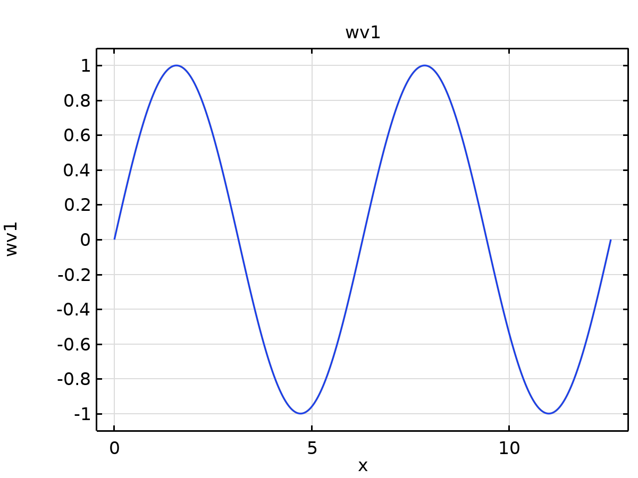

Waveform 1

## Mesh Parts

### Mesh Part 1

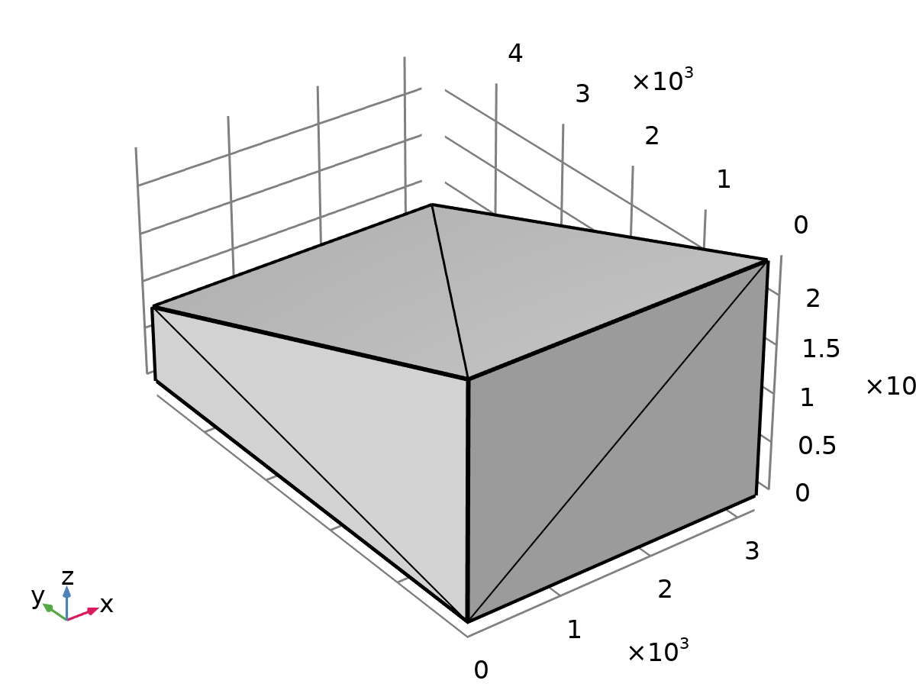

Mesh Part 1

#### Import 1 (imp1)

Information

| **Description** | **Value** |
| --- | --- |
| Source | STL file |
| Last build time | < 1 second |
| Built with | COMSOL 6.3.0.335 (win64), Apr 15, 2025, 2:38:09 AM |

Settings

| **Description** | **Value** |
| --- | --- |
| Filename | C:\Users\Rishabh\Downloads\GreenHouse.stl |
| Create domains | On |

Settings

| **Name** | **SOLID section in file** |
| --- | --- |
| Import 1 |  |

Settings

| **Name** | **SOLID section in file** |
| --- | --- |
| Import 1 |  |

#### Finalize (fin)

Information

| **Description** | **Value** |
| --- | --- |
| Last build time | < 1 second |
| Built with | COMSOL 6.3.0.335 (win64), Apr 15, 2025, 2:38:09 AM |

### Mesh Part 2

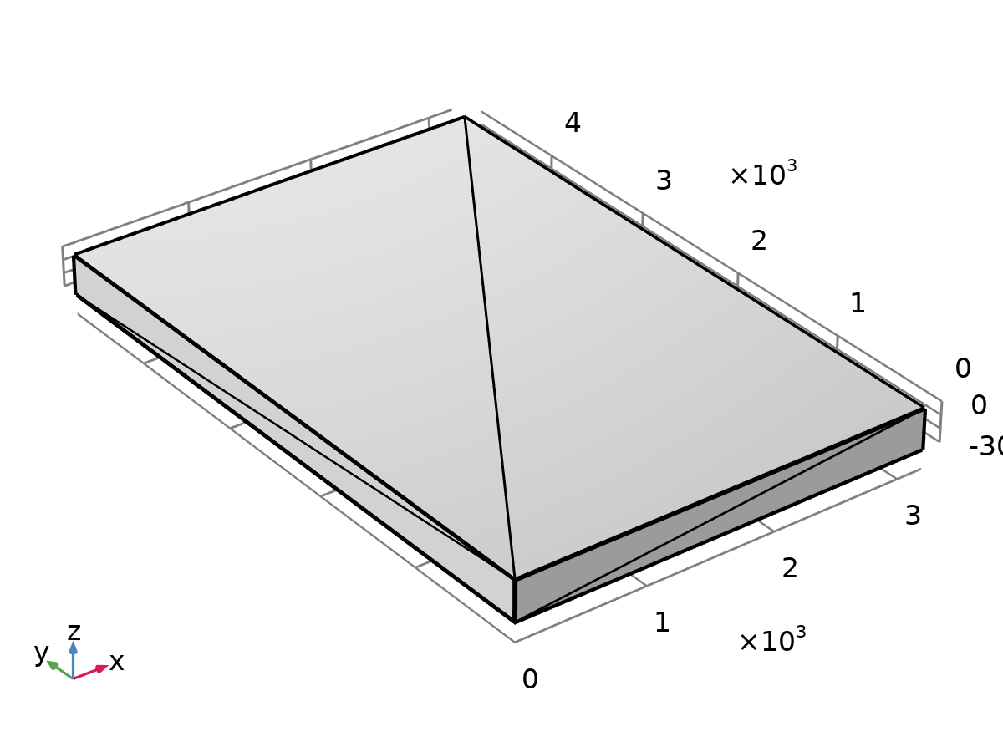

Mesh Part 2

#### Import 1 (imp1)

Information

| **Description** | **Value** |
| --- | --- |
| Source | STL file |
| Last build time | < 1 second |
| Built with | COMSOL 6.3.0.335 (win64), Apr 15, 2025, 2:38:25 AM |

Settings

| **Description** | **Value** |
| --- | --- |
| Filename | C:\Users\Rishabh\Downloads\TopSoil.stl |
| Create domains | On |

Settings

| **Name** | **SOLID section in file** |
| --- | --- |
| Import 1 |  |

Settings

| **Name** | **SOLID section in file** |
| --- | --- |
| Import 1 |  |

#### Finalize (fin)

Information

| **Description** | **Value** |
| --- | --- |
| Last build time | < 1 second |
| Built with | COMSOL 6.3.0.335 (win64), Apr 15, 2025, 2:38:25 AM |

### Mesh Part 3

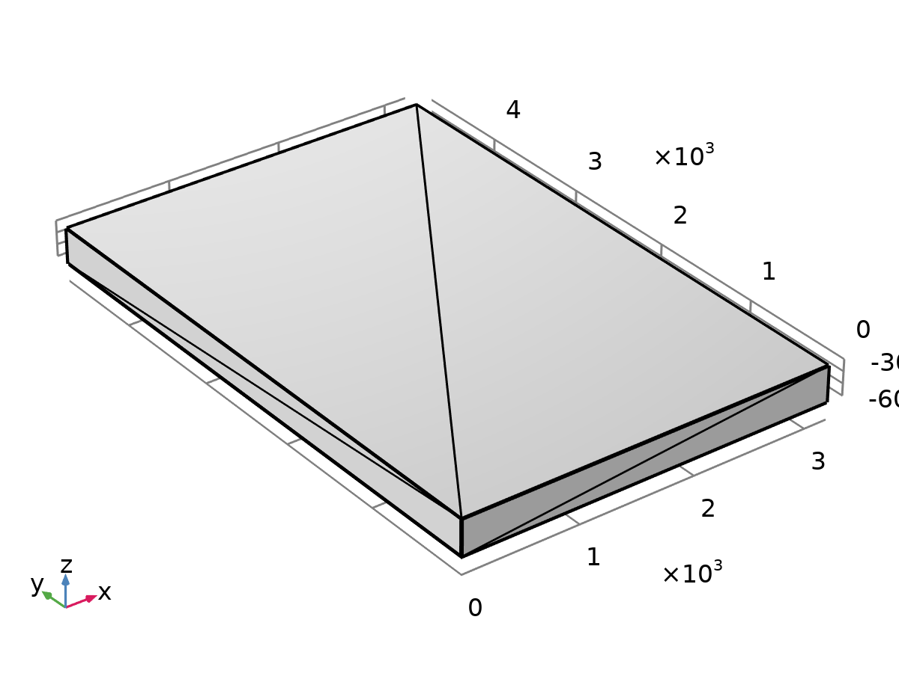

Mesh Part 3

#### Import 1 (imp1)

Information

| **Description** | **Value** |
| --- | --- |
| Source | STL file |
| Last build time | < 1 second |
| Built with | COMSOL 6.3.0.335 (win64), Apr 15, 2025, 2:38:54 AM |

Settings

| **Description** | **Value** |
| --- | --- |
| Filename | C:\Users\Rishabh\Downloads\LowerSoil.stl |
| Create domains | On |

Settings

| **Name** | **SOLID section in file** |
| --- | --- |
| Import 1 |  |

Settings

| **Name** | **SOLID section in file** |
| --- | --- |
| Import 1 |  |

#### Finalize (fin)

Information

| **Description** | **Value** |
| --- | --- |
| Last build time | < 1 second |
| Built with | COMSOL 6.3.0.335 (win64), Apr 15, 2025, 2:38:54 AM |

### Mesh Part 4

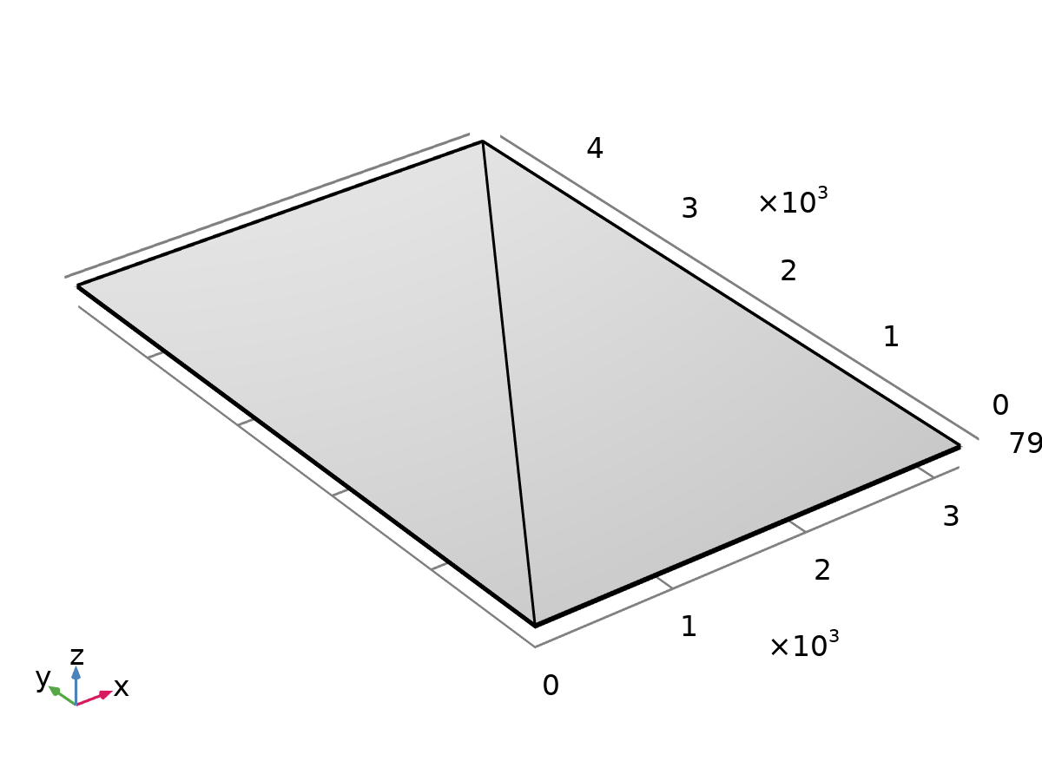

Mesh Part 4

#### Import 1 (imp1)

Information

| **Description** | **Value** |
| --- | --- |
| Source | STL file |
| Last build time | < 1 second |
| Built with | COMSOL 6.3.0.335 (win64), Apr 15, 2025, 2:39:05 AM |

Settings

| **Description** | **Value** |
| --- | --- |
| Filename | C:\Users\Rishabh\Downloads\ThermalScreen.stl |
| Create domains | On |

Settings

| **Name** | **SOLID section in file** |
| --- | --- |
| Import 1 |  |

Settings

| **Name** | **SOLID section in file** |
| --- | --- |
| Import 1 |  |

#### Finalize (fin)

Information

| **Description** | **Value** |
| --- | --- |
| Last build time | < 1 second |
| Built with | COMSOL 6.3.0.335 (win64), Apr 15, 2025, 2:39:05 AM |

## Shared Properties

### Default Model Inputs

|  |  |
| --- | --- |
| Tag | cminpt |

## Materials

### Glass

### Glass (quartz)

Basic

| **Description** | **Value** | **Unit** |
| --- | --- | --- |
| Relative permeability | 1 | 1 |
| Electric conductivity | 1E-14 | S/m |
| Relative permittivity | 4.2 | 1 |
| Density | 2210 | kg/m³ |
| Thermal conductivity | 1.4 | W/(m·K) |
| Heat capacity at constant pressure | 730 | J/(kg·K) |

Refractive index

| **Description** | **Value** |
| --- | --- |
| Refractive index, real part | 1.5 |
| Refractive index, imaginary part | 0 |

### Layered Material 2

### Concrete

Basic

| **Description** | **Value** | **Unit** |
| --- | --- | --- |
| Coefficient of thermal expansion | 1E-5 | 1/K |
| Density | 2300 | kg/m³ |
| Thermal conductivity | 1.8 | W/(m·K) |
| Heat capacity at constant pressure | 880 | J/(kg·K) |

Young's modulus and Poisson's ratio

| **Description** | **Value** | **Unit** |
| --- | --- | --- |
| Young's modulus | 2.5E10 | Pa |
| Poisson's ratio | 0.2 | 1 |

# Component 1

Settings

| **Description** | **Value** |
| --- | --- |
| Unit system | Same as global system (SI) |

## Definitions

### Coordinate Systems

#### Boundary System 1

|  |  |
| --- | --- |
| Coordinate system type | Boundary system |
| Tag | sys1 |

Coordinate names

| **First** | **Second** | **Third** |
| --- | --- | --- |
| t1 | t2 | n |

### Shared Properties

#### Ambient Properties 1

|  |  |
| --- | --- |
| Tag | ampr1 |

Ambient conditions

| **Description** | **Value** |
| --- | --- |
| Temperature | 268[K] + 12.5[K] * (1 + sin(2*pi*(t +13* 3600[s])/86400[s] - pi/2)) |
| Absolute pressure | 10133 |
| Relative humidity | 0.51 |
| Wind speed | 3.31 |
| Precipitation rate | 2.2E-8 |
| Clear sky noon beam normal irradiance | 800[W/m^2] |
| Clear sky noon diffuse horizontal irradiance | 606 |

## Geometry 1

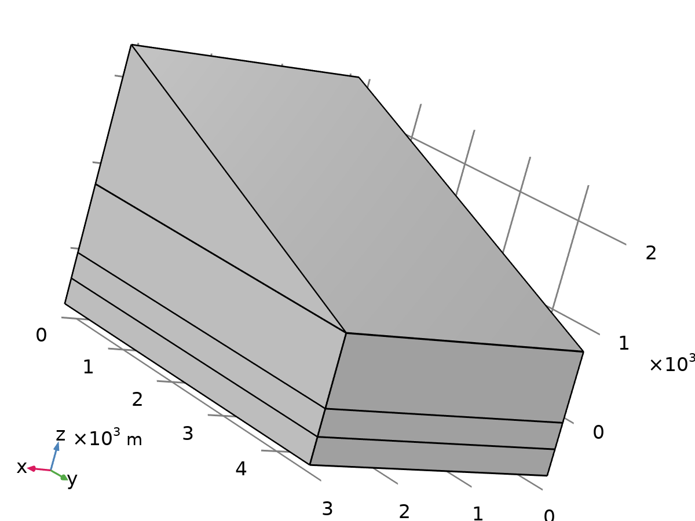

Geometry 1

Units

|  |  |
| --- | --- |
| Length unit | m |
| Angular unit | deg |

Geometry statistics

| **Description** | **Value** |
| --- | --- |
| Space dimension | 3 |
| Number of domains | 5 |
| Number of boundaries | 25 |
| Number of edges | 41 |
| Number of vertices | 22 |

### Import 1 (imp1)

Source

| **Description** | **Value** |
| --- | --- |
| Source | Mesh or 3D printing file (STL, 3MF, PLY) |
| Mesh | Mesh Part 1 |

Information

| **Description** | **Value** |
| --- | --- |
| Build message | Imported 1 solid object from C:\Users\Rishabh\Downloads\GreenHouse.stl via Mesh Part 1. |

### Import 2 (imp2)

Source

| **Description** | **Value** |
| --- | --- |
| Source | Mesh or 3D printing file (STL, 3MF, PLY) |
| Mesh | Mesh Part 2 |

Information

| **Description** | **Value** |
| --- | --- |
| Build message | Imported 1 solid object from C:\Users\Rishabh\Downloads\TopSoil.stl via Mesh Part 2. |

### Import 3 (imp3)

Source

| **Description** | **Value** |
| --- | --- |
| Source | Mesh or 3D printing file (STL, 3MF, PLY) |
| Mesh | Mesh Part 3 |

Information

| **Description** | **Value** |
| --- | --- |
| Build message | Imported 1 solid object from C:\Users\Rishabh\Downloads\LowerSoil.stl via Mesh Part 3. |

### Import 4 (imp4)

Source

| **Description** | **Value** |
| --- | --- |
| Source | Mesh or 3D printing file (STL, 3MF, PLY) |
| Mesh | Mesh Part 4 |

Information

| **Description** | **Value** |
| --- | --- |
| Build message | Imported 1 solid object from C:\Users\Rishabh\Downloads\ThermalScreen.stl via Mesh Part 4. |

### Form Union (fin)

Information

| **Description** | **Value** |
| --- | --- |
| Build message | Formed union of 4 solid objects. Union has 5 domains, 25 boundaries, 41 edges, and 22 vertices. |

## Materials

### Air

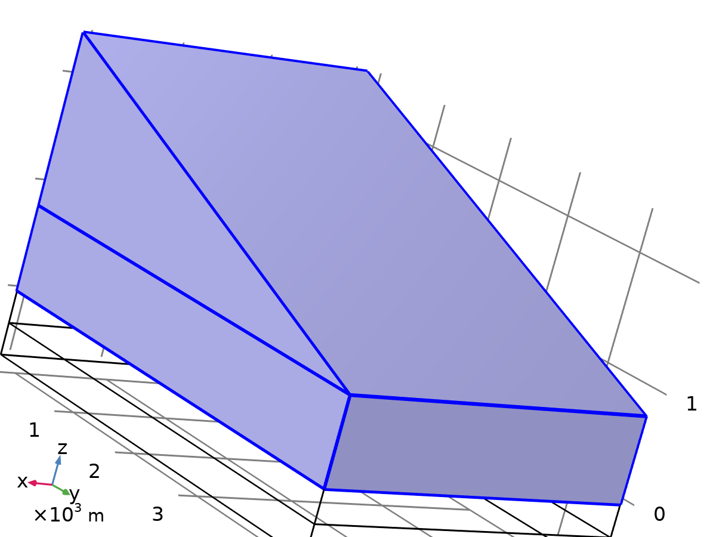

Air

Selection

|  |  |
| --- | --- |
| Geometric entity level | Domain |
| Selection | Geometry geom1: Dimension 3: Domains 3, 5 |

Material parameters

| **Name** | **Value** | **Unit** | **Property group** |
| --- | --- | --- | --- |
| Thermal conductivity | k(T) | W/(m·K) | Basic |
| Specific gas constant | R_const/Mn | J/(kg·K) | Ideal gas |
| Heat capacity at constant pressure | Cp(T) | J/(kg·K) | Ideal gas |

Basic

| **Description** | **Value** | **Unit** |
| --- | --- | --- |
| Heat capacity at constant pressure | Cp(T) | J/(kg·K) |
| Thermal conductivity | k(T) | W/(m·K) |

Ideal gas

| **Description** | **Value** | **Unit** |
| --- | --- | --- |
| Specific gas constant | R_const/Mn | J/(kg·K) |
| Heat capacity at constant pressure | Cp(T) | J/(kg·K) |

### Soil Material

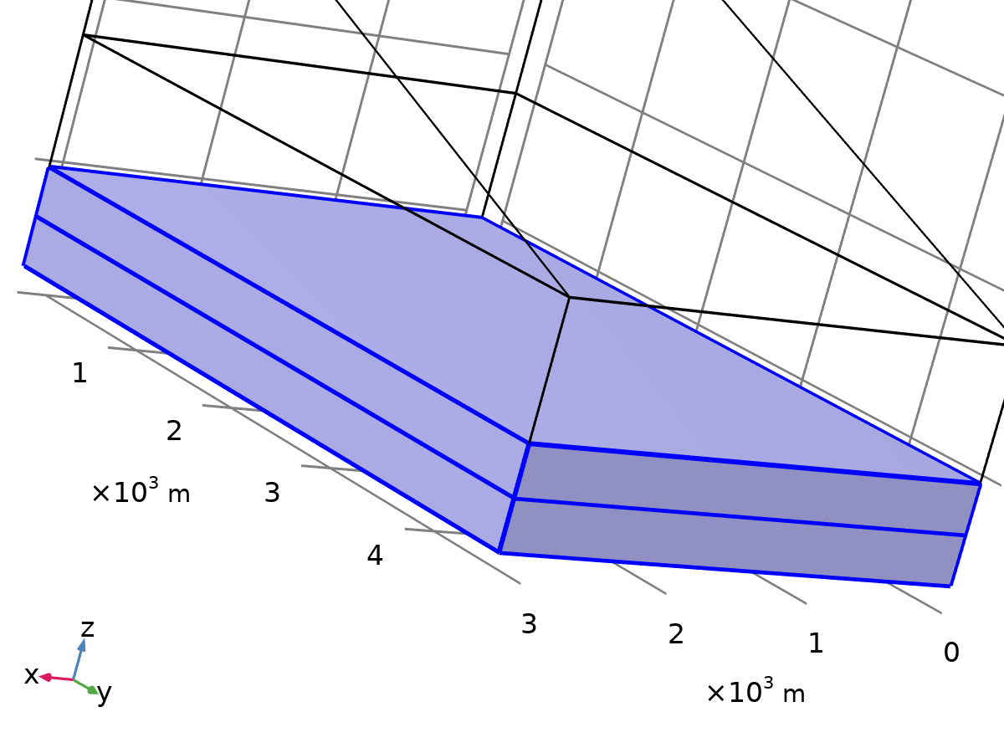

Soil Material

Selection

|  |  |
| --- | --- |
| Geometric entity level | Domain |
| Selection | Geometry geom1: Dimension 3: Domains 1–2 |

Material parameters

| **Name** | **Value** | **Unit** | **Property group** |
| --- | --- | --- | --- |
| Density | 1400 | kg/m³ | Basic |
| Thermal conductivity | 0.6 | W/(m·K) | Basic |
| Heat capacity at constant pressure | 800 | J/(kg·K) | Basic |

Basic

| **Description** | **Value** | **Unit** |
| --- | --- | --- |
| Density | 1400 | kg/m³ |
| Thermal conductivity | 0.6 | W/(m·K) |
| Heat capacity at constant pressure | 800 | J/(kg·K) |

### Layered Material Link 1

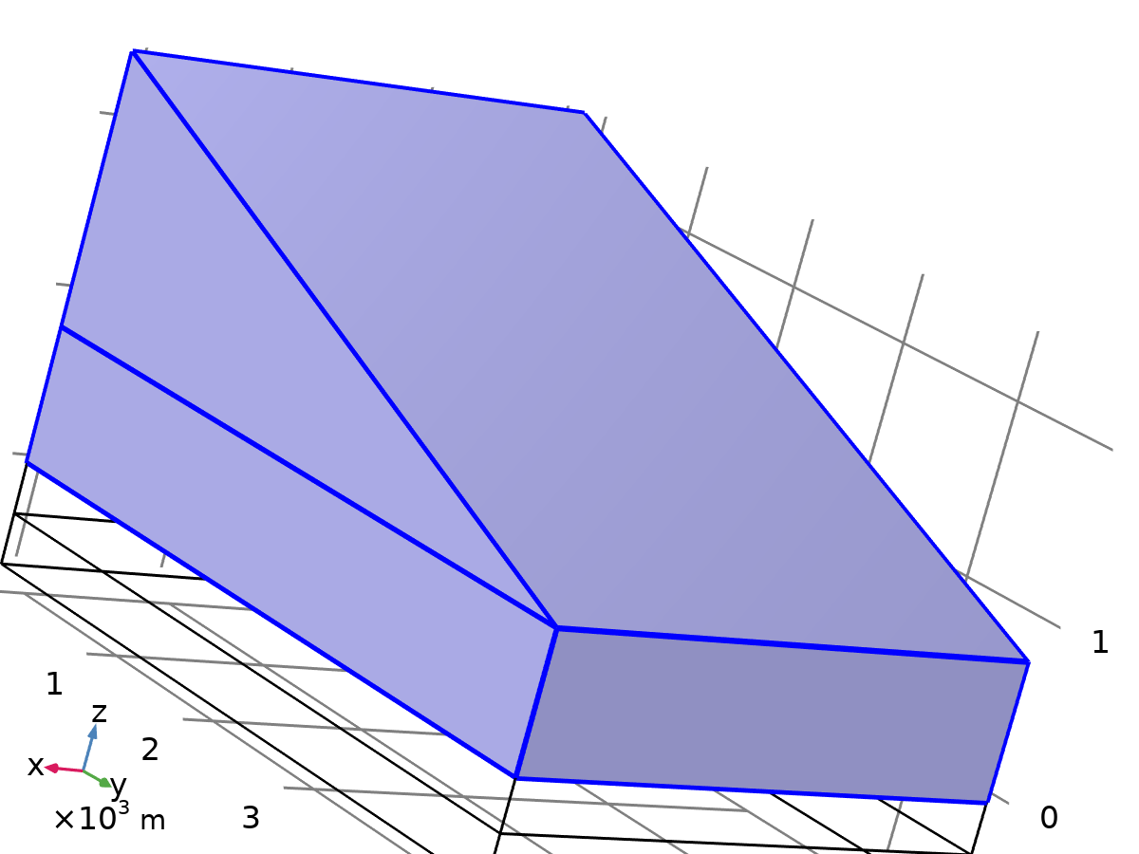

Layered Material Link 1

Selection

|  |  |
| --- | --- |
| Geometric entity level | Boundary |
| Selection | Geometry geom1: Dimension 2: Boundaries 7, 10, 13, 16, 19–20, 23–25 |

Shell

| **Description** | **Value** | **Unit** |
| --- | --- | --- |
| Thickness | ds | m |
| Rotation | rot | rad |
| Mesh elements | 2 | 1 |

### Layered Material Link 2

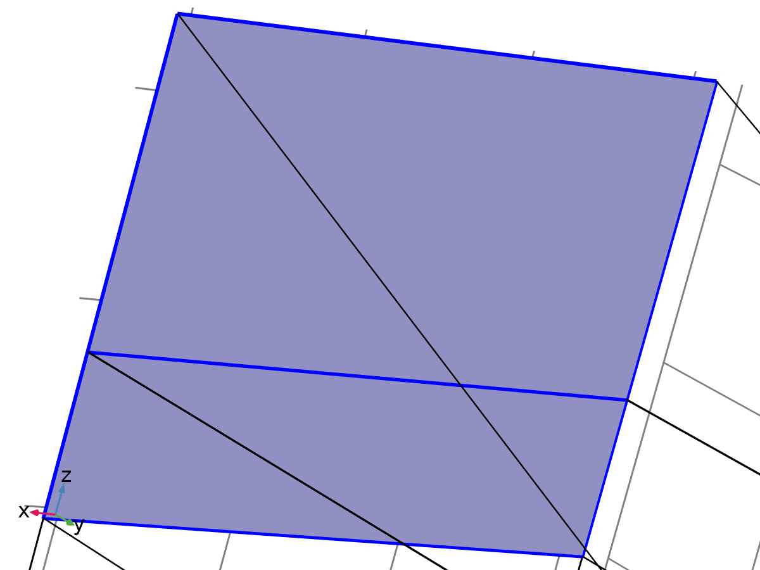

Layered Material Link 2

Selection

|  |  |
| --- | --- |
| Geometric entity level | Boundary |
| Selection | Geometry geom1: Dimension 2: Boundaries 8, 11, 14 |

Shell

| **Description** | **Value** | **Unit** |
| --- | --- | --- |
| Thickness | ds | m |
| Rotation | rot | rad |
| Mesh elements | 2 | 1 |

### (C8H8)n (Polystyrene, PS) (Sultanova et al. 2009: n 0.437-1.05 um)

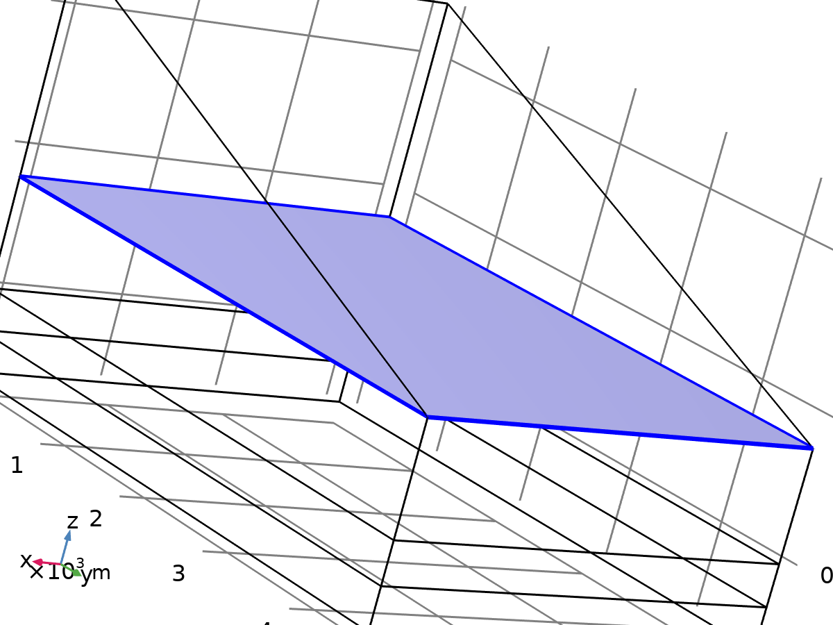

(C8H8)n (Polystyrene, PS) (Sultanova et al. 2009: n 0.437-1.05 um)

Selection

|  |  |
| --- | --- |
| Geometric entity level | Domain |
| Selection | Geometry geom1: Dimension 3: Domain 4 |

Material parameters

| **Name** | **Value** | **Unit** | **Property group** |
| --- | --- | --- | --- |
| Thermal conductivity | 0.03 | W/(m·K) | Basic |
| Density | 1050 | kg/m³ | Basic |
| Heat capacity at constant pressure | 1300 | J/(kg·K) | Basic |

Basic

| **Description** | **Value** | **Unit** |
| --- | --- | --- |
| Thermal conductivity | 0.03 | W/(m·K) |
| Density | 1050 | kg/m³ |
| Heat capacity at constant pressure | 1300 | J/(kg·K) |

## Heat Transfer in Solids and Fluids

Used products

|  |
| --- |
| Heat Transfer Module |
| COMSOL Multiphysics |

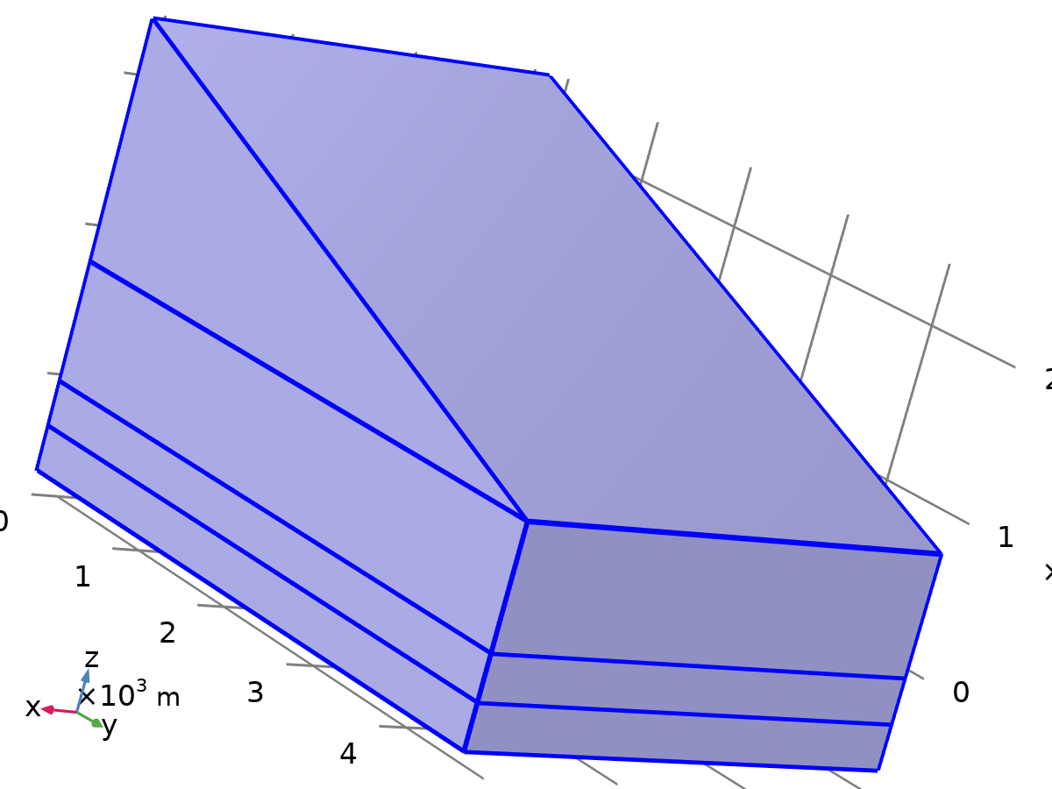

Heat Transfer in Solids and Fluids

Selection

|  |  |
| --- | --- |
| Geometric entity level | Domain |
| Selection | Geometry geom1: Dimension 3: All domains |

Equations

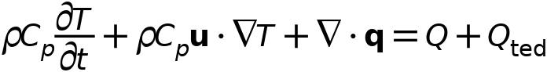



### Interface Settings

#### Discretization

Settings

| **Description** | **Value** |
| --- | --- |
| Temperature | Linear |

Settings

| **Description** | **Value** |
| --- | --- |
| Equation form | Study controlled |

#### Physical Model

Settings

| **Description** | **Value** | **Unit** |
| --- | --- | --- |
| Reference temperature | User defined |  |
| Reference temperature | 293.15 | K |

### Solid 1

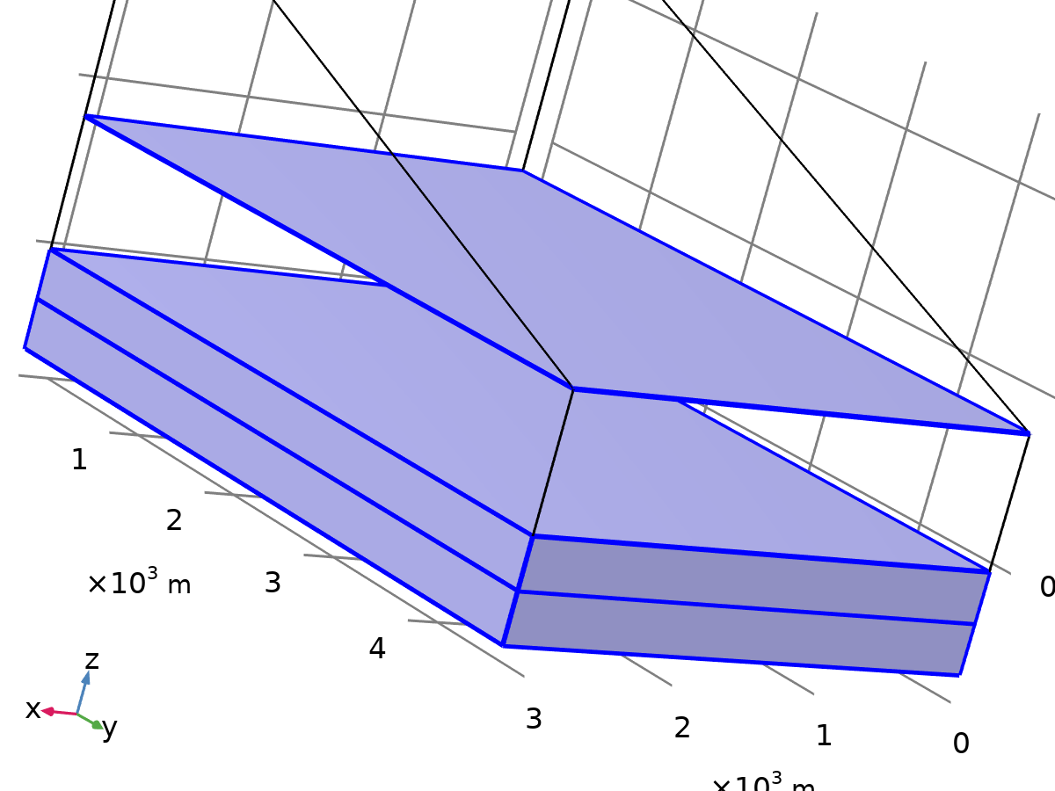

Solid 1

Selection

|  |  |
| --- | --- |
| Geometric entity level | Domain |
| Selection | Geometry geom1: Dimension 3: All domains |

Equations

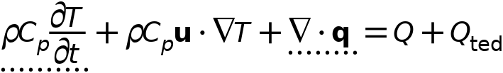



#### Heat Conduction, Solid

Settings

| **Description** | **Value** |
| --- | --- |
| Thermal conductivity | From material |

#### Thermodynamics, Solid

Settings

| **Description** | **Value** |
| --- | --- |
| Density | From material |
| Heat capacity at constant pressure | From material |

#### Coordinate System Selection

Settings

| **Description** | **Value** |
| --- | --- |
| Coordinate system | Global coordinate system |

#### Model Input

Settings

| **Description** | **Value** |
| --- | --- |
| Volume reference temperature | Common model input |
| Absolute pressure | Common model input |

Used products

|  |
| --- |
| COMSOL Multiphysics |

Properties from material

| **Property** | **Material** | **Property group** |
| --- | --- | --- |
| Thermal conductivity | Soil Material | Basic |
| Density | Soil Material | Basic |
| Heat capacity at constant pressure | Soil Material | Basic |
| Thermal conductivity | (C8H8)n (Polystyrene, PS) (Sultanova et al. 2009: n 0.437-1.05 um) | Basic |
| Density | (C8H8)n (Polystyrene, PS) (Sultanova et al. 2009: n 0.437-1.05 um) | Basic |
| Heat capacity at constant pressure | (C8H8)n (Polystyrene, PS) (Sultanova et al. 2009: n 0.437-1.05 um) | Basic |

### Fluid 1



Fluid 1

Selection

|  |  |
| --- | --- |
| Geometric entity level | Domain |
| Selection | Geometry geom1: Dimension 3: Domains 3, 5 |

Equations

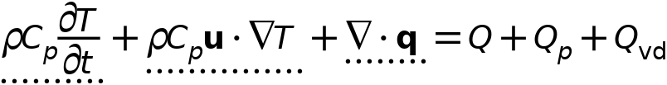



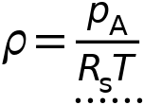

#### Heat Convection

Settings

| **Description** | **Value** |
| --- | --- |
| Velocity field | Common model input |

#### Heat Conduction, Fluid

Settings

| **Description** | **Value** |
| --- | --- |
| Thermal conductivity | From material |

#### Thermodynamics, Fluid

Settings

| **Description** | **Value** |
| --- | --- |
| Fluid type | Ideal gas |
| Gas constant type | Specific gas constant |
| Specific gas constant | From material |
| Specify Cp or γ | Heat capacity at constant pressure |
| Heat capacity at constant pressure | From material |

#### Coordinate System Selection

Settings

| **Description** | **Value** |
| --- | --- |
| Coordinate system | Global coordinate system |

#### Model Input

Settings

| **Description** | **Value** |
| --- | --- |
| Absolute pressure | Common model input |

Used products

|  |
| --- |
| COMSOL Multiphysics |

Properties from material

| **Property** | **Material** | **Property group** |
| --- | --- | --- |
| Specific gas constant | Air | Ideal gas |
| Heat capacity at constant pressure | Air | Ideal gas |
| Thermal conductivity | Air | Basic |

### Initial Values 1



Initial Values 1

Selection

|  |  |
| --- | --- |
| Geometric entity level | Domain |
| Selection | Geometry geom1: Dimension 3: All domains |

#### Initial Values

Settings

| **Description** | **Value** | **Unit** |
| --- | --- | --- |
| Temperature | User defined |  |
| Temperature | 288.15 | K |

Used products

|  |
| --- |
| COMSOL Multiphysics |

### Thermal Insulation 1

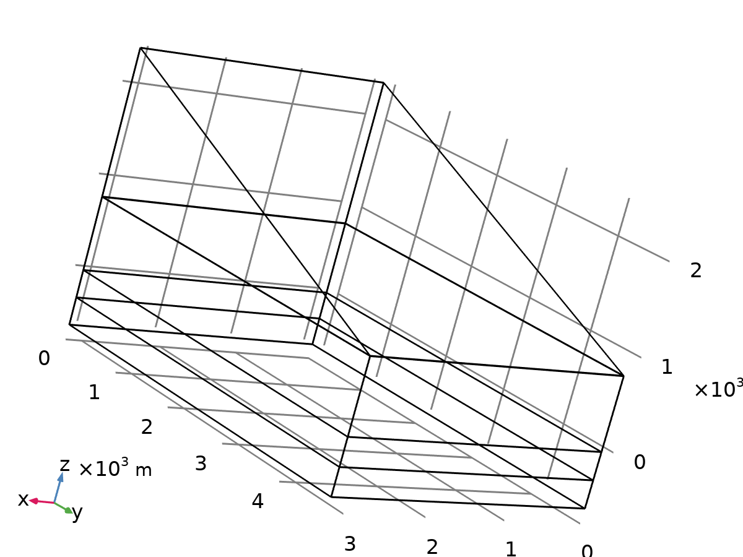

Thermal Insulation 1

Selection

|  |  |
| --- | --- |
| Geometric entity level | Boundary |
| Selection | Geometry geom1: Dimension 2: All boundaries |

Equations



Used products

|  |
| --- |
| COMSOL Multiphysics |

### Heat Flux 1

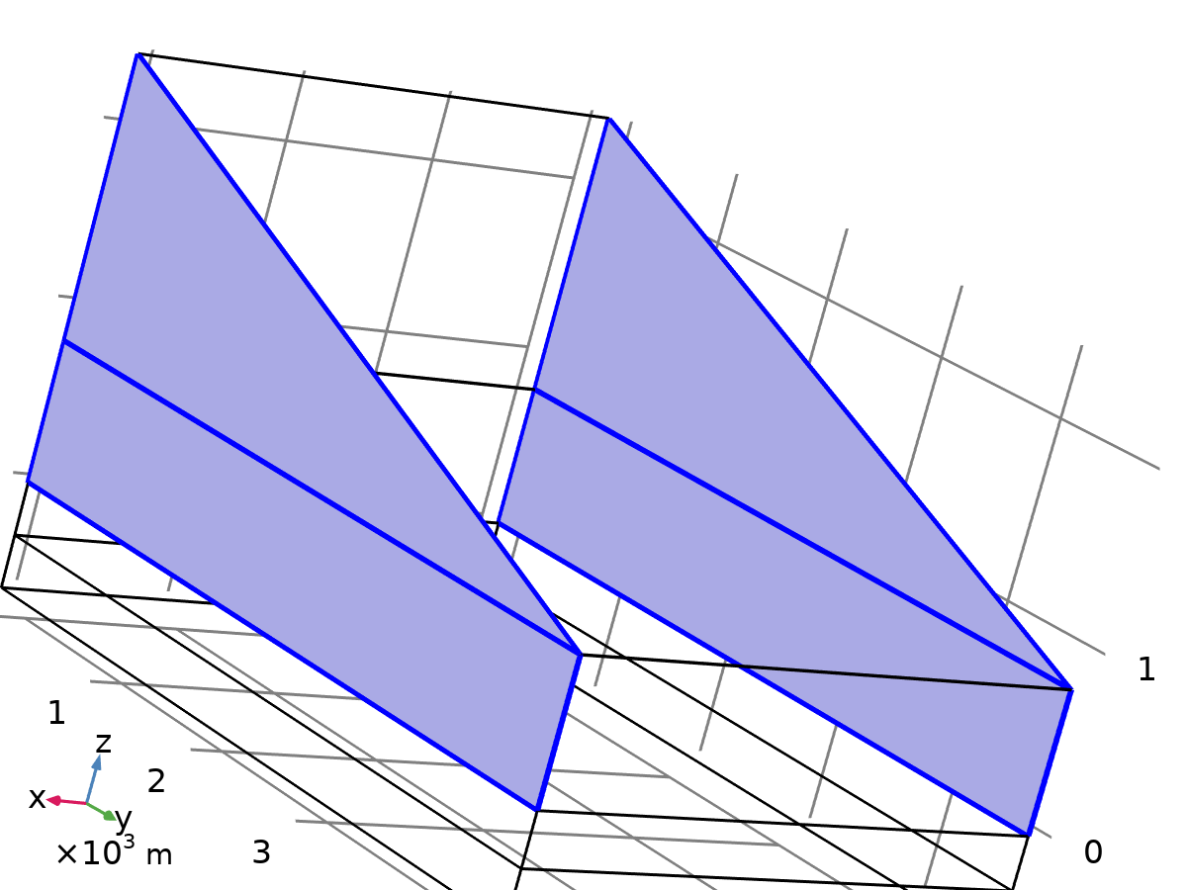

Heat Flux 1

Selection

|  |  |
| --- | --- |
| Geometric entity level | Boundary |
| Selection | Geometry geom1: Dimension 2: Boundaries 7, 13, 23, 25 |

Equations





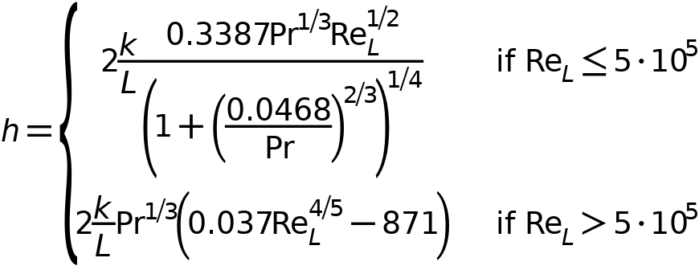

#### Heat Flux

Settings

| **Description** | **Value** | **Unit** |
| --- | --- | --- |
| Flux type | Convective heat flux |  |
| Heat transfer coefficient | External forced convection |  |
| External forced convection | Plate, averaged transfer coefficient |  |
| Plate length | 4800 | m |
| Velocity, fluid | Wind speed (ampr1) |  |
| Fluid | Air |  |
| Absolute pressure | Ambient absolute pressure (ampr1) |  |
| Absolute pressure | Ambient absolute pressure (ampr1) |  |
| External temperature | Ambient temperature (ampr1) |  |

### Heat Flux 2

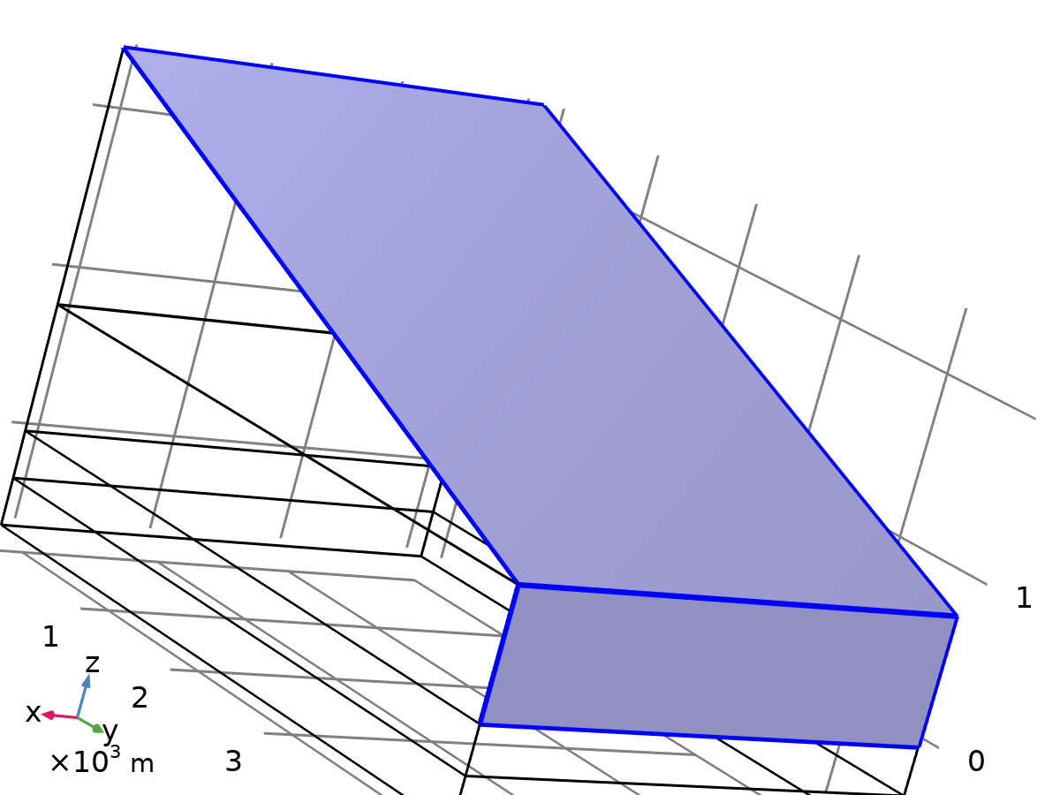

Heat Flux 2

Selection

|  |  |
| --- | --- |
| Geometric entity level | Boundary |
| Selection | Geometry geom1: Dimension 2: Boundaries 16, 19 |

Equations







#### Heat Flux

Settings

| **Description** | **Value** | **Unit** |
| --- | --- | --- |
| Flux type | Convective heat flux |  |
| Heat transfer coefficient | External forced convection |  |
| External forced convection | Plate, averaged transfer coefficient |  |
| Plate length | 3200 | m |
| Velocity, fluid | Wind speed (ampr1) |  |
| Fluid | Air |  |
| Absolute pressure | Ambient absolute pressure (ampr1) |  |
| Absolute pressure | Ambient absolute pressure (ampr1) |  |
| External temperature | Ambient temperature (ampr1) |  |

## Heat Transfer in Solids 2

Used products

|  |
| --- |
| COMSOL Multiphysics |



Heat Transfer in Solids 2

Selection

|  |  |
| --- | --- |
| Geometric entity level | Domain |
| Selection | Geometry geom1: Dimension 3: Domains 1–2, 4 |

Equations

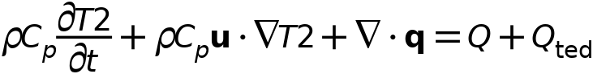



### Interface Settings

#### Discretization

Settings

| **Description** | **Value** |
| --- | --- |
| Temperature | Quadratic Lagrange |

Settings

| **Description** | **Value** |
| --- | --- |
| Equation form | Study controlled |

#### Physical Model

Settings

| **Description** | **Value** | **Unit** |
| --- | --- | --- |
| Reference temperature | User defined |  |
| Reference temperature | 293.15 | K |

### Solid 1



Solid 1

Selection

|  |  |
| --- | --- |
| Geometric entity level | Domain |
| Selection | Geometry geom1: Dimension 3: All domains |

Equations

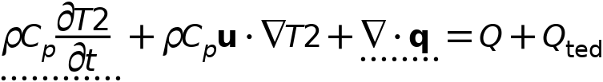



#### Heat Conduction, Solid

Settings

| **Description** | **Value** |
| --- | --- |
| Thermal conductivity | From material |

#### Thermodynamics, Solid

Settings

| **Description** | **Value** |
| --- | --- |
| Density | From material |
| Heat capacity at constant pressure | From material |

#### Coordinate System Selection

Settings

| **Description** | **Value** |
| --- | --- |
| Coordinate system | Global coordinate system |

#### Model Input

Settings

| **Description** | **Value** | **Unit** |
| --- | --- | --- |
| Volume reference temperature | Common model input |  |
| Absolute pressure | User defined |  |
| Absolute pressure | 1.0133E5 | Pa |

Properties from material

| **Property** | **Material** | **Property group** |
| --- | --- | --- |
| Thermal conductivity | Soil Material | Basic |
| Density | Soil Material | Basic |
| Heat capacity at constant pressure | Soil Material | Basic |
| Thermal conductivity | (C8H8)n (Polystyrene, PS) (Sultanova et al. 2009: n 0.437-1.05 um) | Basic |
| Density | (C8H8)n (Polystyrene, PS) (Sultanova et al. 2009: n 0.437-1.05 um) | Basic |
| Heat capacity at constant pressure | (C8H8)n (Polystyrene, PS) (Sultanova et al. 2009: n 0.437-1.05 um) | Basic |

### Initial Values 1



Initial Values 1

Selection

|  |  |
| --- | --- |
| Geometric entity level | Domain |
| Selection | Geometry geom1: Dimension 3: All domains |

#### Initial Values

Settings

| **Description** | **Value** | **Unit** |
| --- | --- | --- |
| Temperature | User defined |  |
| Temperature | 288.15 | K |

### Thermal Insulation 1



Thermal Insulation 1

Selection

|  |  |
| --- | --- |
| Geometric entity level | Boundary |
| Selection | Geometry geom1: Dimension 2: All boundaries |

Equations



## Surface-to-Surface Radiation

Used products

|  |
| --- |
| Heat Transfer Module |
| COMSOL Multiphysics |



Surface-to-Surface Radiation

Selection

|  |  |
| --- | --- |
| Geometric entity level | Boundary |
| Selection | Geometry geom1: Dimension 2: All boundaries |

Equations









### Interface Settings

#### Discretization

Settings

| **Description** | **Value** |
| --- | --- |
| Surface radiosity | Linear |

Settings

| **Description** | **Value** |
| --- | --- |
| Equation form | Study controlled |

#### Radiation Settings

Settings

| **Description** | **Value** |
| --- | --- |
| Use radiation groups | Off |
| Transparent media refractive index | 1 |
| Surface-to-surface radiation method | Hemicube |
| Radiation resolution | 256 |
| Use adaptive resolution coarsening | Off |
| Wavelength dependence of radiative properties | Constant |

### Diffuse Surface 1

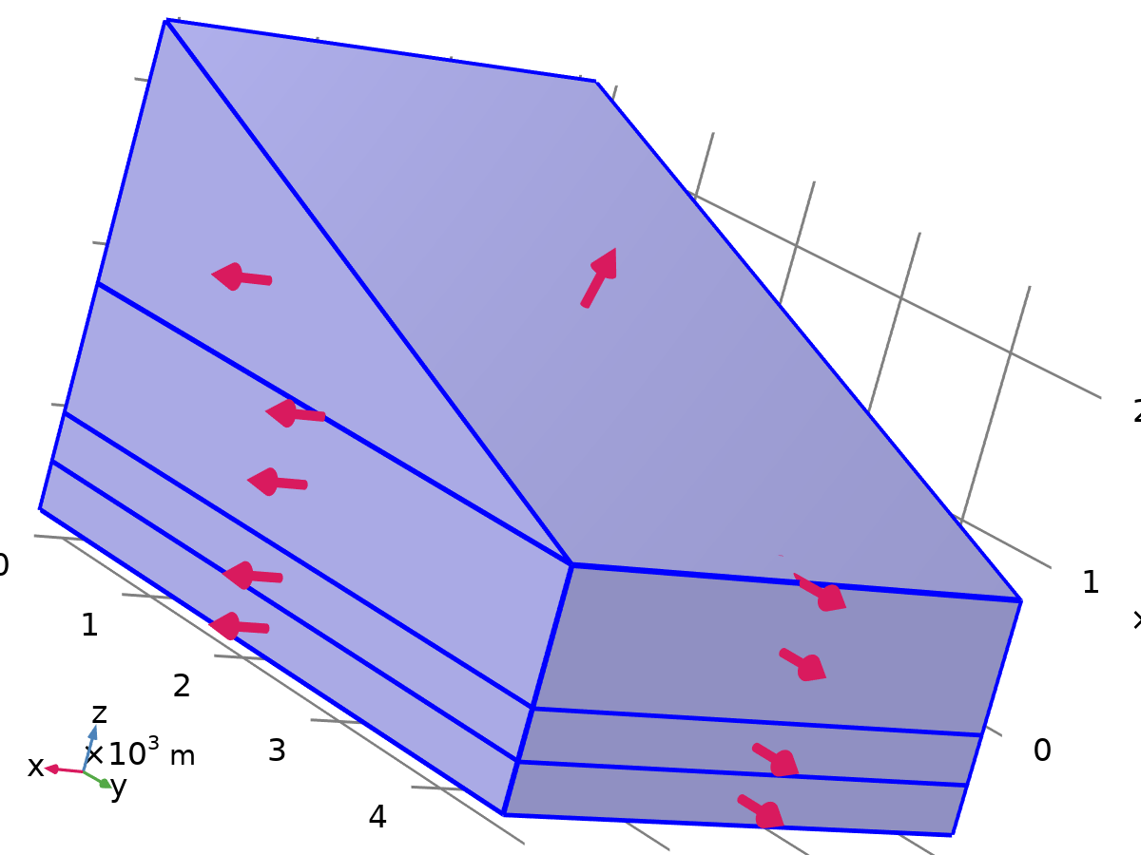

Diffuse Surface 1

Selection

|  |  |
| --- | --- |
| Geometric entity level | Boundary |
| Selection | Geometry geom1: Dimension 2: All boundaries |

Equations

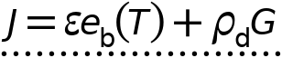





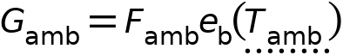





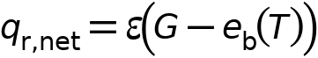

#### Radiation Direction

Settings

| **Description** | **Value** |
| --- | --- |
| Description | Emitted radiation direction: |
| Emitted radiation direction | Both sides |

#### Ambient

Settings

| **Description** | **Value** |
| --- | --- |
| Define ambient temperature on each side | Off |
| Ambient temperature | Ambient temperature (ampr1) |
| Define ambient emissivity on each side | Off |
| Ambient emissivity | Blackbody |
| Include diffuse irradiance | Off |

#### Surface Emissivity

Settings

| **Description** | **Value** |
| --- | --- |
| Define properties on each side | Off |
| Emissivity | User defined |
| Emissivity | 0.8 |

### Initial Values 1



Initial Values 1

Selection

|  |  |
| --- | --- |
| Geometric entity level | Boundary |
| Selection | Geometry geom1: Dimension 2: All boundaries |

Equations

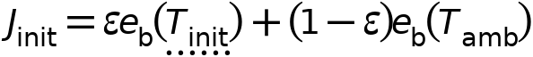

#### Initial Values

Settings

| **Description** | **Value** |
| --- | --- |
| Initial value | Blackbody/Graybody |

## Multiphysics

### Heat Transfer with Surface-to-Surface Radiation 1

Used products

|  |
| --- |
| Heat Transfer Module |
| COMSOL Multiphysics |



Heat Transfer with Surface-to-Surface Radiation 1

Selection

|  |  |
| --- | --- |
| Geometric entity level | Boundary |
| Selection | Geometry geom1: Dimension 2: Boundaries 1–25 |

Equations



#### Coupled Interfaces

Settings

| **Description** | **Value** |
| --- | --- |
| Heat transfer | Heat Transfer in Solids and Fluids (ht) |
| Surface-to-surface radiation | Surface-to - Surface Radiation (rad) |

#### Variables

| **Name** | **Expression** | **Unit** | **Description** | **Selection** | **Details** |
| --- | --- | --- | --- | --- | --- |
| ht.rflux | rad.rflux | W/m² | Radiative heat flux | Boundaries 1–25 | + operation |
| ht.ndflux_u | if(ht.isSolving,0,if(ht.TuIsDown,0,-0.5*((1+rad.opaque)*rad.rfluxu_band+(1-rad.opaque)*rad.rfluxd_band))+if(ht.TdIsUp,-0.5*((1+rad.opaque)*rad.rfluxd_band+(1-rad.opaque)*rad.rfluxu_band),0)) | W/m² | Internal normal conductive heat flux, upside | Boundaries 6, 9, 12, 15 | + operation |
| ht.ndflux_d | if(ht.isSolving,0,if(ht.TdIsUp,0,-0.5*((1+rad.opaque)*rad.rfluxd_band+(1-rad.opaque)*rad.rfluxu_band))+if(ht.TuIsDown,-0.5*((1+rad.opaque)*rad.rfluxu_band+(1-rad.opaque)*rad.rfluxd_band),0)) | W/m² | Internal normal conductive heat flux, downside | Boundaries 6, 9, 12, 15 | + operation |
| ht.ntflux_contrib | 0.5*((1+rad.opaque)*rad.rfluxu_band+(1-rad.opaque)*rad.rfluxd_band+(1+rad.opaque)*rad.rfluxd_band+(1-rad.opaque)*rad.rfluxu_band) | W/m² | Boundary sources and fluxes contribution | Boundaries 6, 9, 12, 15 | + operation |
| rad.dfltopaque | ht.dfltopaque | 1 | Opaque | Domains 1–5 |  |
| rad.Tinit | ht.Tinit | K | Initial temperature | Boundaries 1–25 |  |
| htrad1.T | T | K | Temperature | Boundaries 1–25 |  |
| htrad1.Tradu | ht.Tradu | K | Upside temperature | Boundaries 1–25 |  |
| htrad1.Tradd | ht.Tradd | K | Downside temperature | Boundaries 1–25 |  |
| htrad1.d | ht.d | 1 | Thickness | Boundaries 1–25 |  |
| htrad1.T_cmi | model.input.T_cmi | K | Temperature | Global | Meta |
| htrad1.T_cmiu | model.input.T_cmiu | K | Upside temperature | Global | Meta |
| htrad1.T_cmid | model.input.T_cmid | K | Downside temperature | Global | Meta |

#### Weak Expressions

| **Weak expression** | **Integration order** | **Integration frame** | **Selection** |
| --- | --- | --- | --- |
| rad.rfluxoutu_band*test(rad.Tu_band)*htrad1.d | 2 | Spatial | Boundaries 1–25 |
| rad.rfluxinu_band*test(rad.Tu_band)*htrad1.d | 1 | Spatial | Boundaries 1–25 |
| rad.rfluxoutd_band*test(rad.Td_band)*htrad1.d | 2 | Spatial | Boundaries 1–25 |
| rad.rfluxind_band*test(rad.Td_band)*htrad1.d | 1 | Spatial | Boundaries 1–25 |

### Heat Transfer with Surface-to-Surface Radiation 2

Used products

|  |
| --- |
| Heat Transfer Module |
| COMSOL Multiphysics |



Heat Transfer with Surface-to-Surface Radiation 2

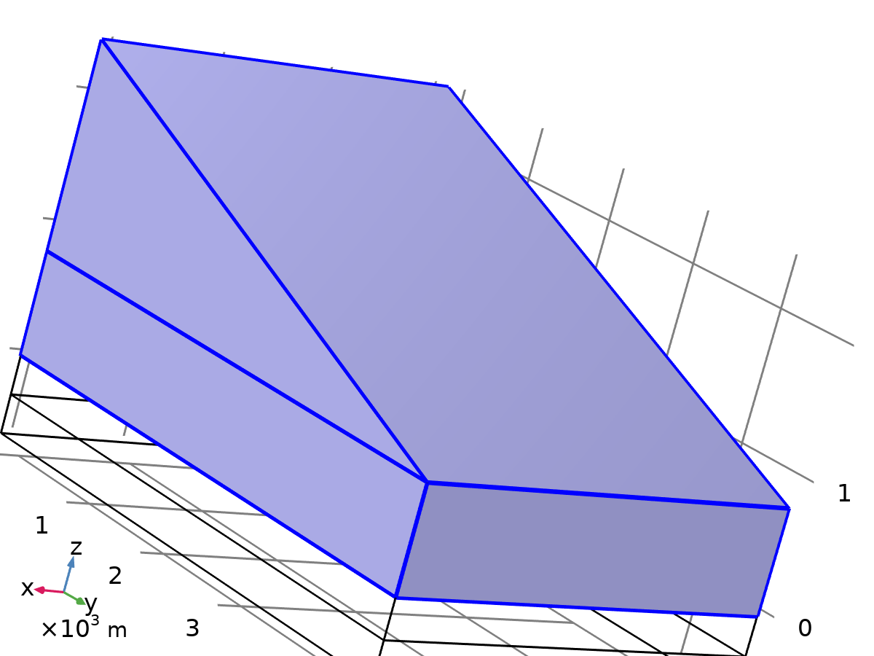

Complementary selection

Selection

|  |  |
| --- | --- |
| Geometric entity level | Boundary |
| Selection | Geometry geom1: Dimension 2: All boundaries |

Equations



#### Coupled Interfaces

Settings

| **Description** | **Value** |
| --- | --- |
| Heat transfer | Heat Transfer in Solids 2 (ht2) |
| Surface-to-surface radiation | Surface-to - Surface Radiation (rad) |

#### Variables

| **Name** | **Expression** | **Unit** | **Description** | **Selection** | **Details** |
| --- | --- | --- | --- | --- | --- |
| ht2.rflux | rad.rflux | W/m² | Radiative heat flux | Boundaries 1–6, 9–12, 15, 17–18, 20–22, 24 | + operation |
| ht2.ndflux_u | if(ht2.isSolving,0,if(ht2.TuIsDown,0,-0.5*((1+rad.opaque)*rad.rfluxu_band+(1-rad.opaque)*rad.rfluxd_band))+if(ht2.TdIsUp,-0.5*((1+rad.opaque)*rad.rfluxd_band+(1-rad.opaque)*rad.rfluxu_band),0)) | W/m² | Internal normal conductive heat flux, upside | Boundary 6 | + operation |
| ht2.ndflux_d | if(ht2.isSolving,0,if(ht2.TdIsUp,0,-0.5*((1+rad.opaque)*rad.rfluxd_band+(1-rad.opaque)*rad.rfluxu_band))+if(ht2.TuIsDown,-0.5*((1+rad.opaque)*rad.rfluxu_band+(1-rad.opaque)*rad.rfluxd_band),0)) | W/m² | Internal normal conductive heat flux, downside | Boundary 6 | + operation |
| ht2.ntflux_contrib | 0.5*((1+rad.opaque)*rad.rfluxu_band+(1-rad.opaque)*rad.rfluxd_band+(1+rad.opaque)*rad.rfluxd_band+(1-rad.opaque)*rad.rfluxu_band) | W/m² | Boundary sources and fluxes contribution | Boundary 6 | + operation |
| rad.dfltopaque | ht2.dfltopaque | 1 | Opaque | Domains 1–2, 4 |  |
| rad.Tinit | ht2.Tinit | K | Initial temperature | Boundaries 1–6, 9–12, 15, 17–18, 20–22, 24 |  |
| htrad2.T | T2 | K | Temperature | Boundaries 1–6, 9–12, 15, 17–18, 20–22, 24 |  |
| htrad2.T | htrad2.T_cmi | K | Temperature | Boundaries 7–8, 13–14, 16, 19, 23, 25 |  |
| htrad2.Tradu | ht2.Tradu | K | Upside temperature | Boundaries 1–6, 9–12, 15, 17–18, 20–22, 24 |  |
| htrad2.Tradu | htrad2.T_cmiu | K | Upside temperature | Boundaries 7–8, 13–14, 16, 19, 23, 25 |  |
| htrad2.Tradd | ht2.Tradd | K | Downside temperature | Boundaries 1–6, 9–12, 15, 17–18, 20–22, 24 |  |
| htrad2.Tradd | htrad2.T_cmid | K | Downside temperature | Boundaries 7–8, 13–14, 16, 19, 23, 25 |  |
| htrad2.d | ht2.d | 1 | Thickness | Boundaries 1–6, 9–12, 15, 17–18, 20–22, 24 |  |
| htrad2.d | ht2.d | 1 | Thickness | Boundaries 7–8, 13–14, 16, 19, 23, 25 |  |
| htrad2.T_cmi | model.input.T_cmi | K | Temperature | Global | Meta |
| htrad2.T_cmiu | model.input.T_cmiu | K | Upside temperature | Global | Meta |
| htrad2.T_cmid | model.input.T_cmid | K | Downside temperature | Global | Meta |

#### Weak Expressions

| **Weak expression** | **Integration order** | **Integration frame** | **Selection** |
| --- | --- | --- | --- |
| rad.rfluxoutu_band*test(rad.Tu_band)*htrad2.d | 4 | Spatial | Boundaries 1–6, 9–12, 15, 17–18, 20–22, 24 |
| rad.rfluxinu_band*test(rad.Tu_band)*htrad2.d | 2 | Spatial | Boundaries 1–6, 9–12, 15, 17–18, 20–22, 24 |
| rad.rfluxoutd_band*test(rad.Td_band)*htrad2.d | 4 | Spatial | Boundaries 1–6, 9–12, 15, 17–18, 20–22, 24 |
| rad.rfluxind_band*test(rad.Td_band)*htrad2.d | 2 | Spatial | Boundaries 1–6, 9–12, 15, 17–18, 20–22, 24 |

## Mesh 1

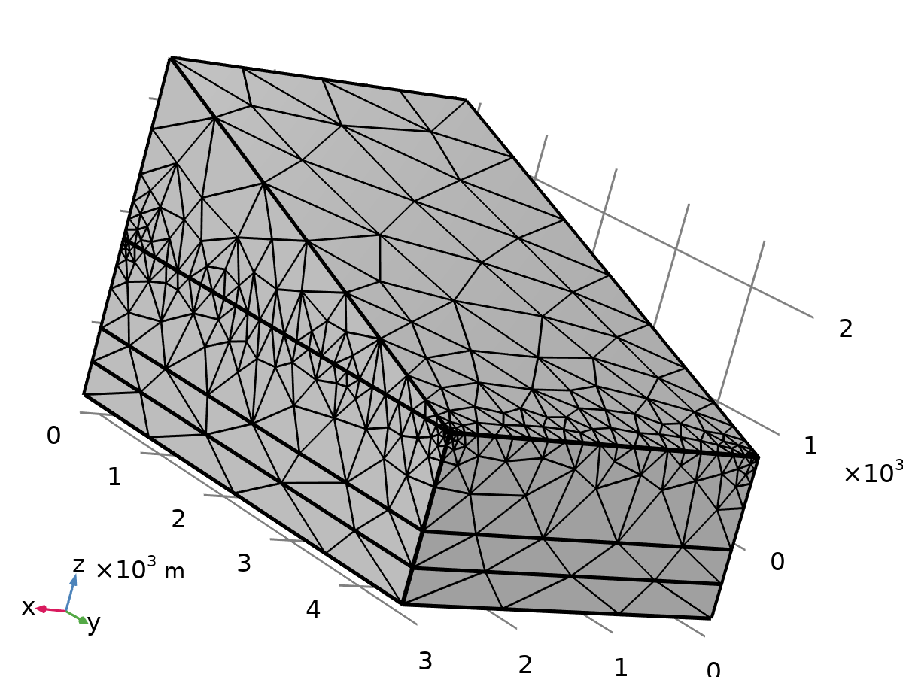

Mesh 1

### Size (size)

Settings

| **Description** | **Value** |
| --- | --- |
| Maximum element size | 2867 |
| Minimum element size | 180 |
| Resolution of narrow regions | 0.1 |
| Maximum element growth rate | 2 |
| Predefined size | Extremely coarse |
| Custom element size | Custom |

### Free Tetrahedral 1 (ftet1)

Selection

|  |  |
| --- | --- |
| Geometric entity level | Domain |
| Selection | Remaining |

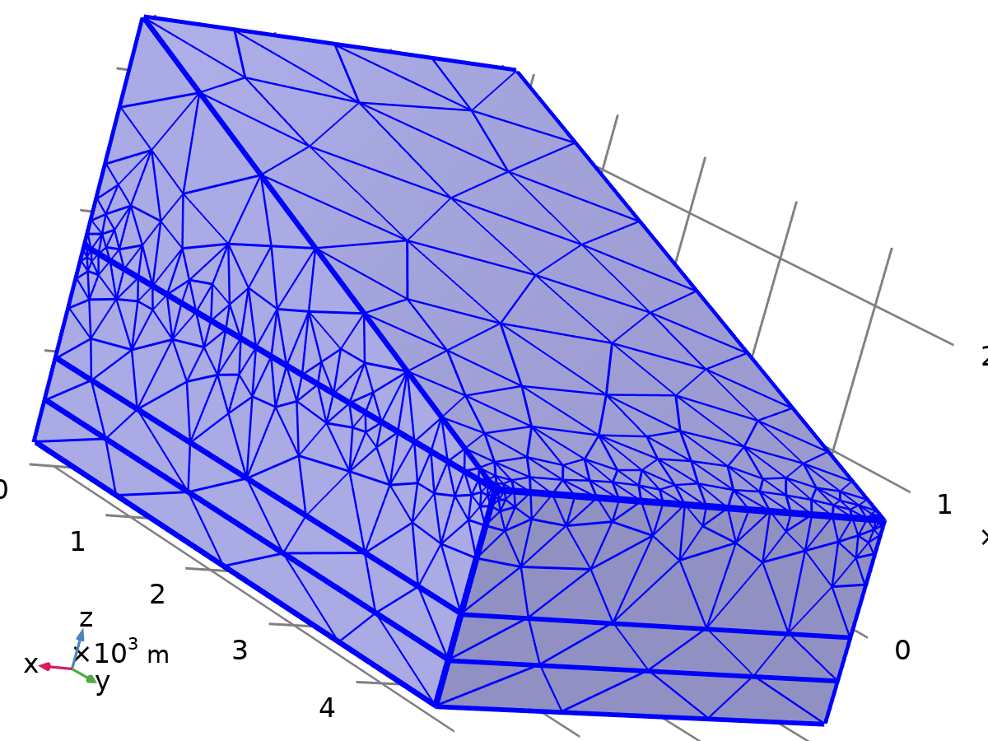

Free Tetrahedral 1

Settings

| **Description** | **Value** |
| --- | --- |
| Avoid inverted curved elements | On |

Information

| **Description** | **Value** |
| --- | --- |
| Last build time | 2 seconds |
| Built with | COMSOL 6.3.0.335 (win64), Apr 23, 2025, 4:13:00 PM |

# Study 1

Computation information

|  |  |
| --- | --- |
| Computation time | 51 s |

## Time Dependent

| **Times** | **Unit** |
| --- | --- |
| range(0,1,100) | h |

Study settings

| **Description** | **Value** |
| --- | --- |
| Include geometric nonlinearity | Off |

Study settings

| **Description** | **Value** |
| --- | --- |
| Time unit | h |
| Output times | {0, 1, 2, 3, 4, 5, 6, 7, 8, 9, 10, 11, 12, 13, 14, 15, 16, 17, 18, 19, 20, 21, 22, 23, 24, 25, 26, 27, 28, 29, 30, 31, 32, 33, 34, 35, 36, 37, 38, 39, 40, 41, 42, 43, 44, 45, 46, 47, 48, 49, 50, 51, 52, 53, 54, 55, 56, 57, 58, 59, 60, 61, 62, 63, 64, 65, 66, 67, 68, 69, 70, 71, 72, 73, 74, 75, 76, 77, 78, 79, 80, 81, 82, 83, 84, 85, 86, 87, 88, 89, 90, 91, 92, 93, 94, 95, 96, 97, 98, 99, 100} |

Physics and variables selection

| **Key** | **Solve for** |
| --- | --- |
| Heat Transfer in Solids and Fluids (ht) | On |
| Heat Transfer in Solids 2 (ht2) | On |
| Surface-to-Surface Radiation (rad) | On |

Physics and variables selection

| **Feature** | **Solve for** |
| --- | --- |
| Heat Transfer with Surface-to-Surface Radiation 1 (htrad1) | On |
| Heat Transfer with Surface-to-Surface Radiation 2 (htrad2) | On |

Store in output

| **Interface** | **Output** | **Selection** |
| --- | --- | --- |
| Heat Transfer in Solids and Fluids (ht) | Physics controlled |  |
| Heat Transfer in Solids 2 (ht2) | Physics controlled |  |
| Surface-to-Surface Radiation (rad) | Physics controlled |  |
| Heat Transfer with Surface-to-Surface Radiation 1 (htrad1) |  |  |
| Heat Transfer with Surface-to-Surface Radiation 2 (htrad2) |  |  |

Mesh selection

| **Component** | **Mesh** |
| --- | --- |
| Component 1 | Mesh 1 |

## Solver Configurations

### Solution 1

#### Compile Equations: Time Dependent (st1)

Study and step

| **Description** | **Value** |
| --- | --- |
| Use study | Study 1 |
| Use study step | Time Dependent |

#### Dependent Variables 1 (v1)

General

| **Description** | **Value** |
| --- | --- |
| Defined by study step | Step 1: Time Dependent |

Initial value calculation constants

| **Constant name** | **Initial-value source** |
| --- | --- |
| t | {range(0, 1, 100)}[h] |
| timestep | 0.1[h] |

##### Surface Radiosity, Downside (comp1.rad.dsurf1.Jd_band) (comp1_rad_dsurf1_Jd_band)

General

| **Description** | **Value** |
| --- | --- |
| Field components | comp1.rad.dsurf1.Jd_band |

Scaling

| **Description** | **Value** |
| --- | --- |
| Method | Initial - value based |

##### Surface Radiosity, Upside (comp1.rad.dsurf1.Ju_band) (comp1_rad_dsurf1_Ju_band)

General

| **Description** | **Value** |
| --- | --- |
| Field components | comp1.rad.dsurf1.Ju_band |

Scaling

| **Description** | **Value** |
| --- | --- |
| Method | Initial - value based |

##### Temperature (comp1.T) (comp1_T)

General

| **Description** | **Value** |
| --- | --- |
| Field components | comp1.T |
| Internal variables | {comp1.ht.dt2Inv_T, comp1.uflux.T, comp1.dflux.T} |

##### Temperature (comp1.T2) (comp1_T2)

General

| **Description** | **Value** |
| --- | --- |
| Field components | comp1.T2 |
| Internal variables | {comp1.ht2.dt2Inv_T, comp1.uflux.T2, comp1.dflux.T2} |

#### Time-Dependent Solver 1 (t1)

General

| **Description** | **Value** |
| --- | --- |
| Defined by study step | Step 1: Time Dependent |
| Time unit | h |
| Output times | {0, 1, 2, 3, 4, 5, 6, 7, 8, 9, 10, 11, 12, 13, 14, 15, 16, 17, 18, 19, 20, 21, 22, 23, 24, 25, 26, 27, 28, 29, 30, 31, 32, 33, 34, 35, 36, 37, 38, 39, 40, 41, 42, 43, 44, 45, 46, 47, 48, 49, 50, 51, 52, 53, 54, 55, 56, 57, 58, 59, 60, 61, 62, 63, 64, 65, 66, 67, 68, 69, 70, 71, 72, 73, 74, 75, 76, 77, 78, 79, 80, 81, 82, 83, 84, 85, 86, 87, 88, 89, 90, 91, 92, 93, 94, 95, 96, 97, 98, 99, 100} |

Absolute tolerance

| **Field** | **Method** | **Tolerance method** | **Tolerance factor** | **Derivative tolerance method** | **Time derivative factor** | **Tolerance** | **Tolerance for time derivatives** |
| --- | --- | --- | --- | --- | --- | --- | --- |
| Surface Radiosity, Downside (comp1.rad.dsurf1.Jd_band) | Use global | Factor | 0.1 | Automatic | 1 | 0.001 | 0.001 |
| Surface Radiosity, Upside (comp1.rad.dsurf1.Ju_band) | Use global | Factor | 0.1 | Automatic | 1 | 0.001 | 0.001 |
| Temperature (comp1.T) | Use global | Factor | 0.1 | Automatic | 1 | 0.001 | 0.001 |
| Temperature (comp1.T2) | Use global | Factor | 0.1 | Automatic | 1 | 0.001 | 0.001 |

Time stepping

| **Description** | **Value** |
| --- | --- |
| Maximum BDF order | 2 |
| Error estimation | Exclude algebraic |

##### Segregated 1 (se1)

General

| **Description** | **Value** |
| --- | --- |
| Tolerance factor | 0.1 |
| Stabilization and acceleration | Anderson acceleration |
| Dimension of iteration space | 5 |
| Mixing parameter | 0.9 |
| Iteration delay | 1 |

###### Temperature (ss1)

General

| **Description** | **Value** |
| --- | --- |
| Variables | Temperature (comp1.T) |
| Linear solver | Direct, heat transfer variables (ht) |

Method and termination

| **Description** | **Value** |
| --- | --- |
| Damping factor | 0.8 |
| Jacobian update | Once per time step |

###### Temperature (2) (ss2)

General

| **Description** | **Value** |
| --- | --- |
| Variables | Temperature (comp1.T2) |
| Linear solver | Direct, heat transfer variables (ht2) |

Method and termination

| **Description** | **Value** |
| --- | --- |
| Damping factor | 0.8 |
| Jacobian update | Once per time step |

###### Radiosity (ss3)

General

| **Description** | **Value** |
| --- | --- |
| Variables | {Surface Radiosity, Upside (comp1.rad.dsurf1.Ju_band), Surface Radiosity, Downside (comp1.rad.dsurf1.Jd_band)} |
| Linear solver | Direct, radiation variables |

Method and termination

| **Description** | **Value** |
| --- | --- |
| Damping factor | 0.8 |
| Jacobian update | Once per time step |

###### Lower Limit 1 (ll1)

Lower limit

| **Description** | **Value** |
| --- | --- |
| Lower limits (field variables) | comp1.T2 0 comp1.T 0 |

##### Direct, heat transfer variables (ht) (d1)

General

| **Description** | **Value** |
| --- | --- |
| Solver | PARDISO |
| Pivoting perturbation | 1E-13 |

##### Direct, heat transfer variables (ht2) (d2)

General

| **Description** | **Value** |
| --- | --- |
| Solver | PARDISO |
| Pivoting perturbation | 1E-13 |

##### Direct, radiation variables (d3)

General

| **Description** | **Value** |
| --- | --- |
| Solver | PARDISO |
| Pivoting perturbation | 1E-13 |

# Results

## Datasets

### Study 1/Solution 1

Solution

| **Description** | **Value** |
| --- | --- |
| Solution | Solution 1 (sol1) |
| Component | Component 1 (comp1) |

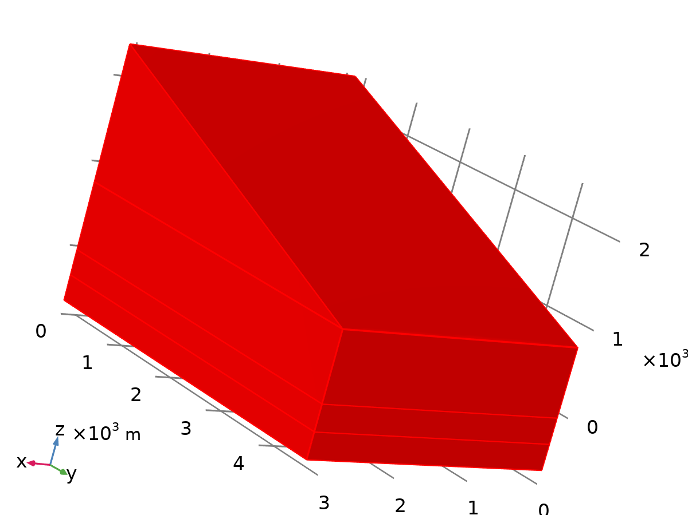

Dataset: Study 1/Solution 1

## Tables

### Evaluation 3D

Interactive 3D values

| **x** | **y** | **z** | **Value** |
| --- | --- | --- | --- |
| 1.5322E-13 | 2276.8 | -213.2 | 292.97 |

## Plot Groups

### Temperature (ht)

[COMSOLlink[]]

Volume: Temperature (K)

### 1D Plot Group 2

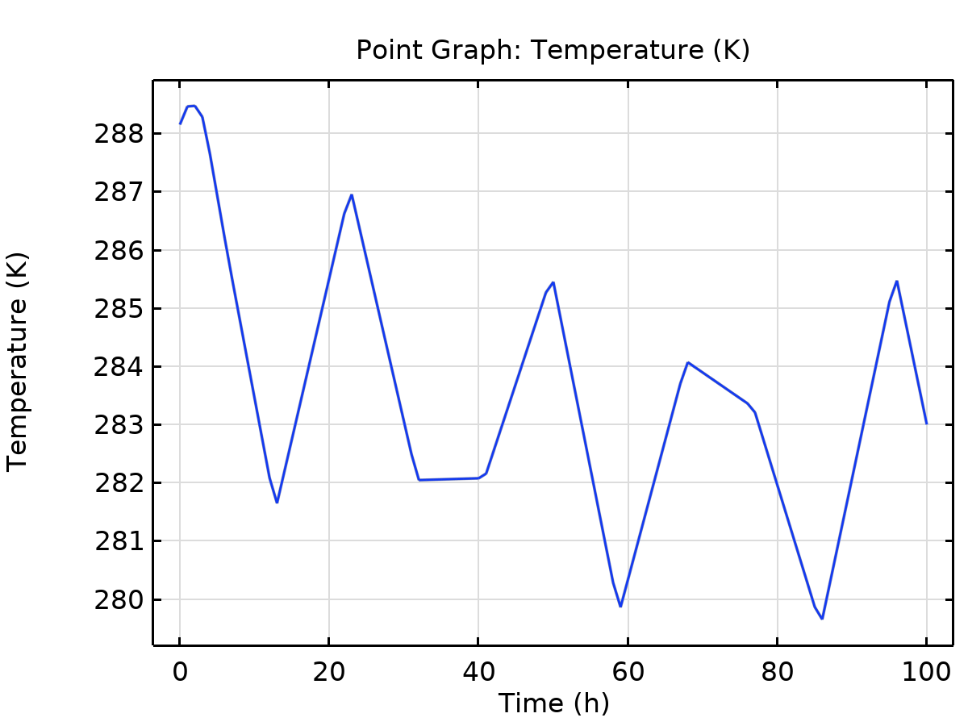

Point Graph: Temperature (K)